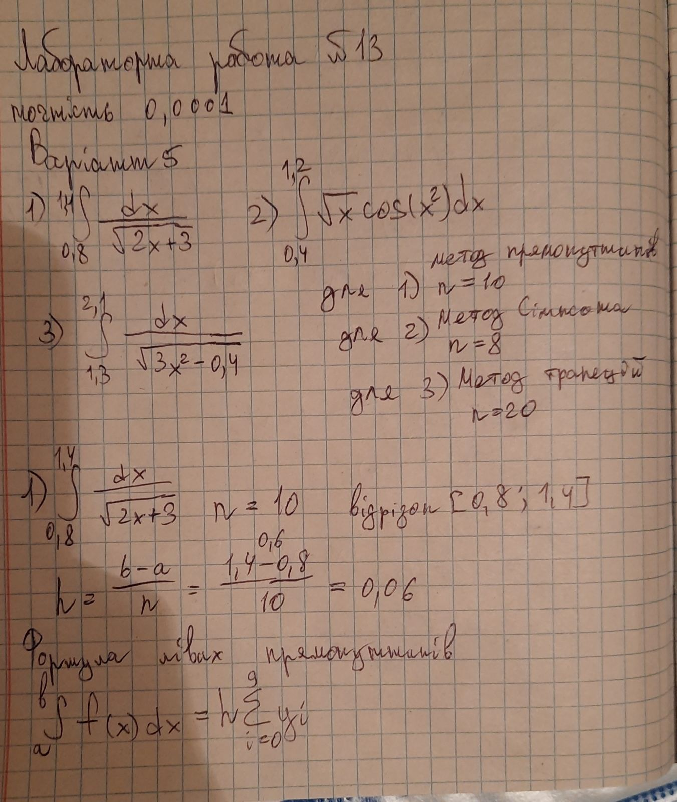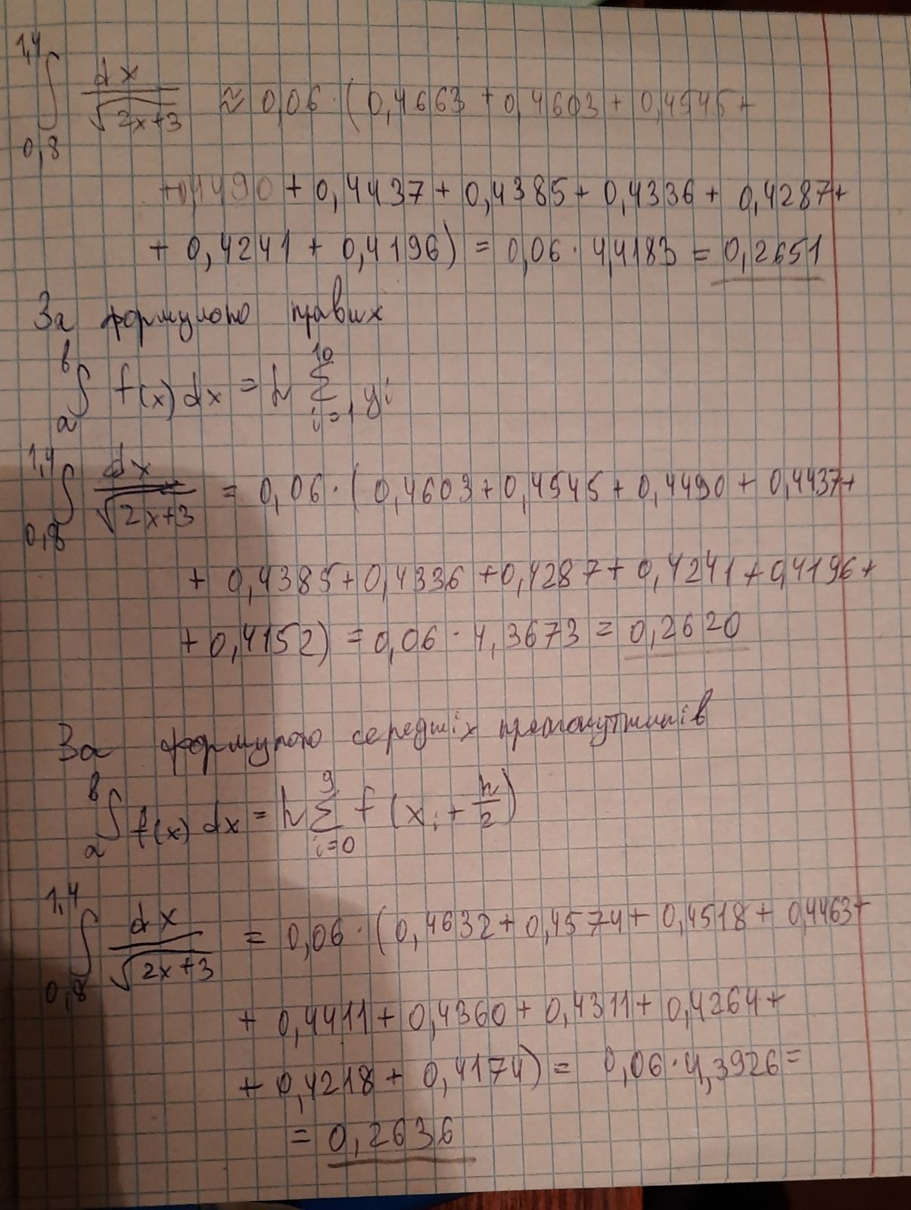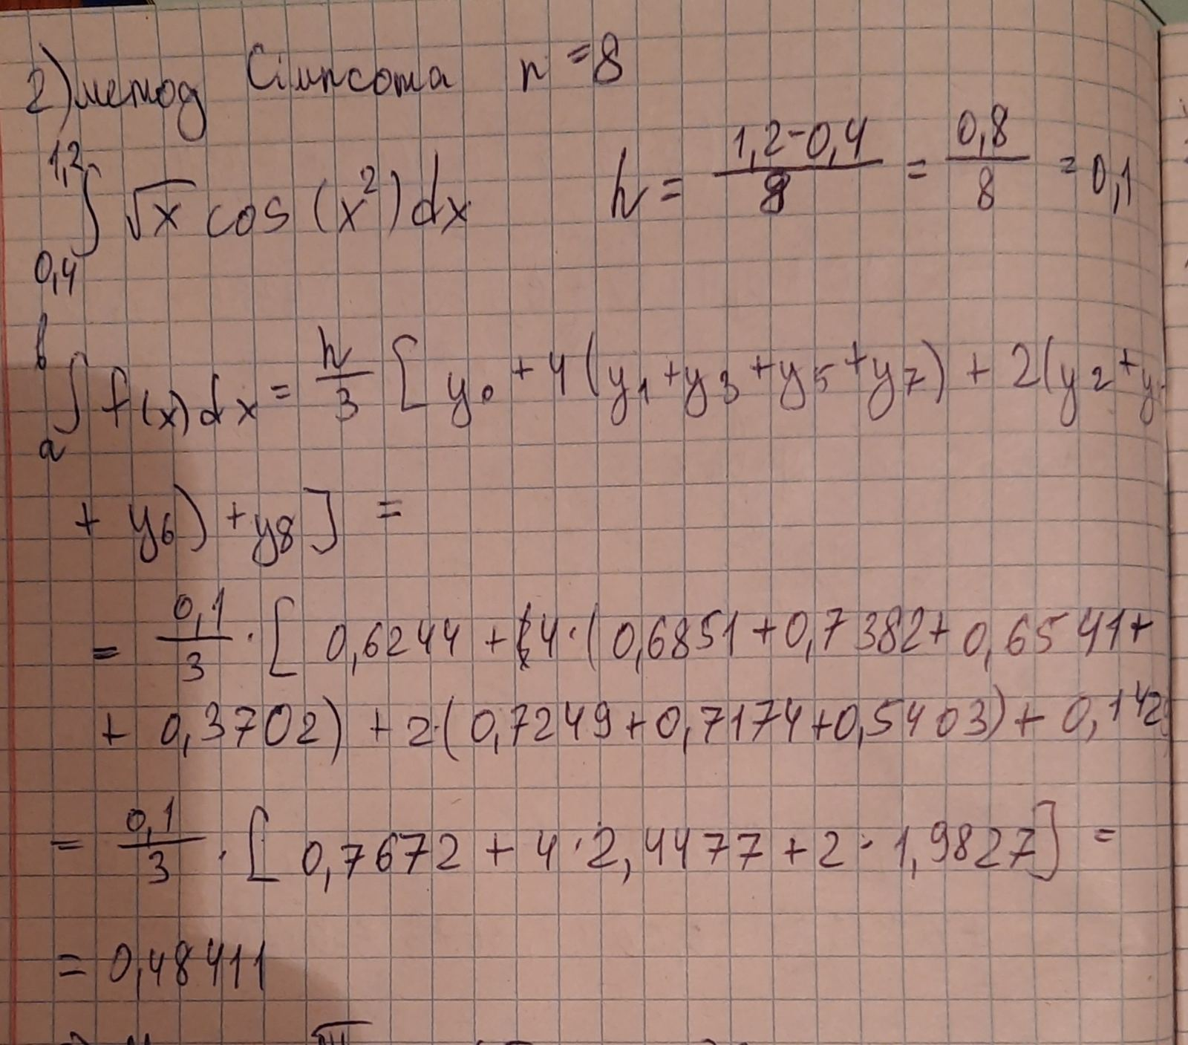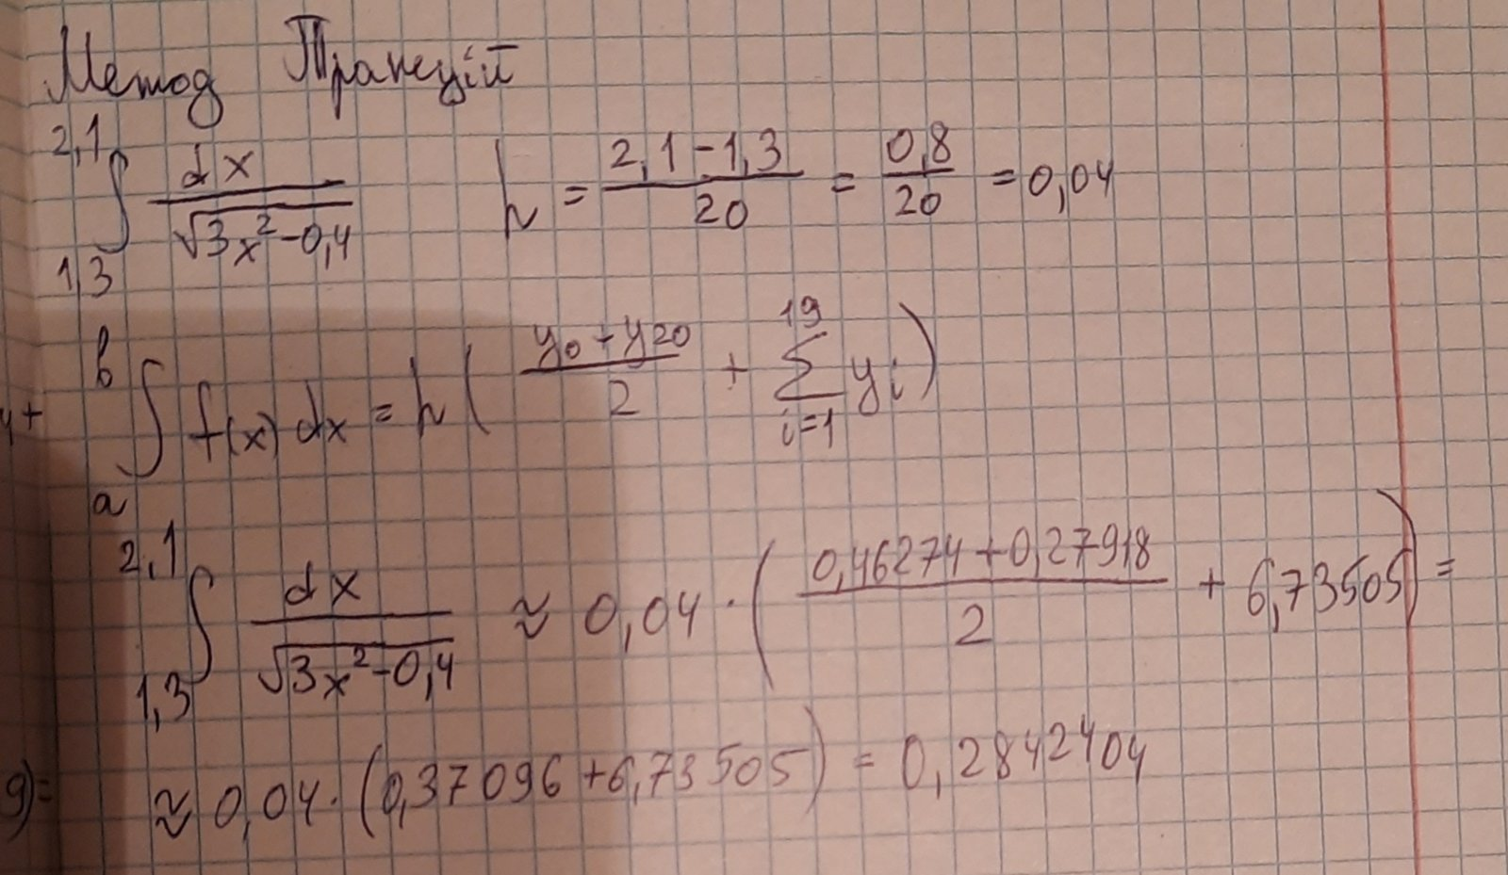

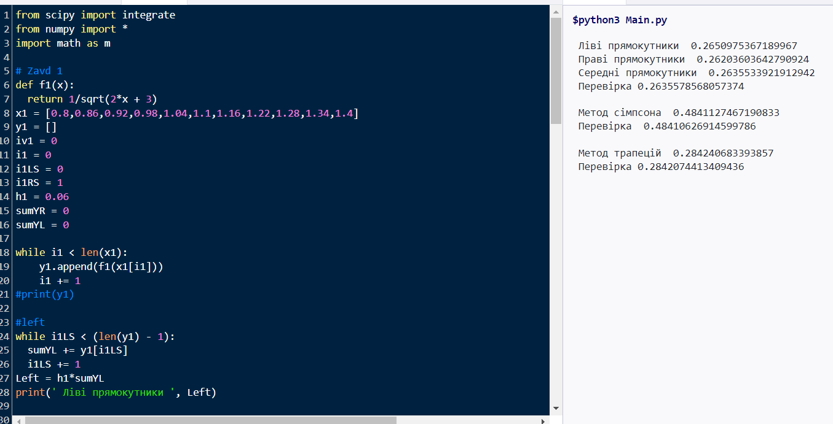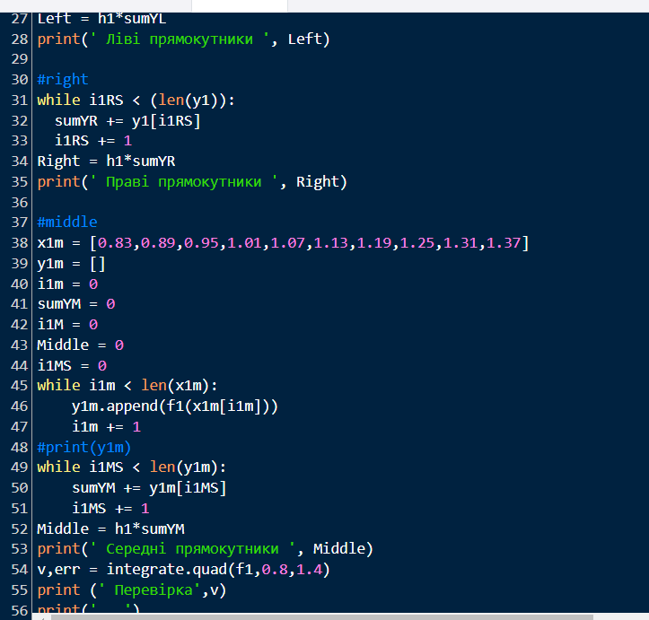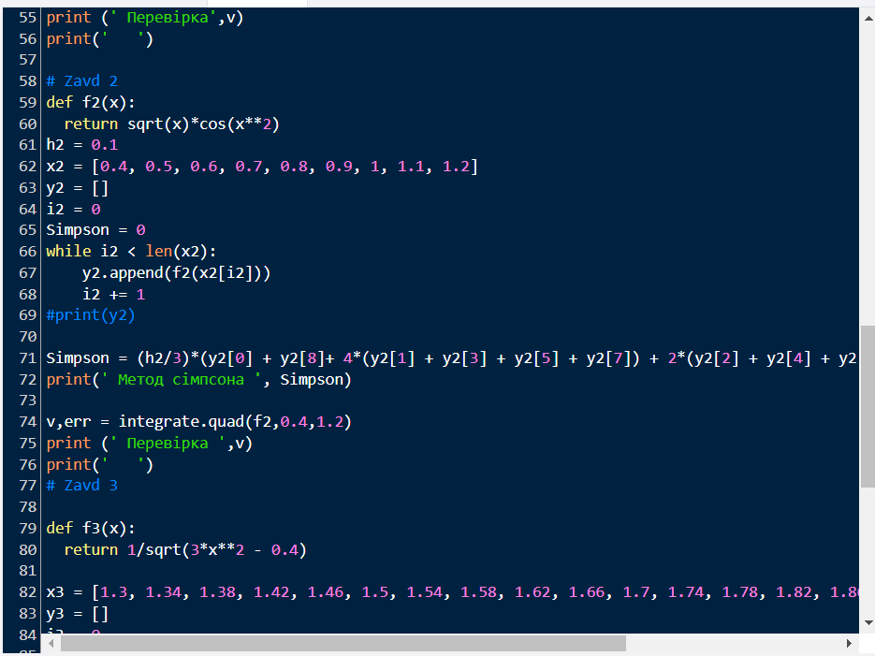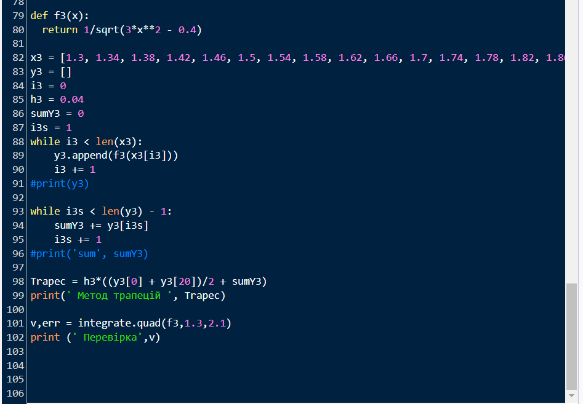

Текст кода

from scipy import integrate

from numpy import *

import math as m

# Zavd 1

def f1(x):

return 1/sqrt(2*x + 3)

x1 = [0.8,0.86,0.92,0.98,1.04,1.1,1.16,1.22,1.28,1.34,1.4]

y1 = []

iv1 = 0

i1 = 0

i1LS = 0

i1RS = 1

h1 = 0.06

sumYR = 0

sumYL = 0

while i1 < len(x1):

y1.append(f1(x1[i1]))

i1 += 1

#print(y1)

#left

while i1LS < (len(y1) - 1):

sumYL += y1[i1LS]

i1LS += 1

Left = h1*sumYL

print(' Ліві прямокутники ', Left)

#right

while i1RS < (len(y1)):

sumYR += y1[i1RS]

i1RS += 1

Right = h1*sumYR

print(' Праві прямокутники ', Right)

#middle

x1m = [0.83,0.89,0.95,1.01,1.07,1.13,1.19,1.25,1.31,1.37]

y1m = []

i1m = 0

sumYM = 0

i1M = 0

Middle = 0

i1MS = 0

while i1m < len(x1m):

y1m.append(f1(x1m[i1m]))

i1m += 1

#print(y1m)

while i1MS < len(y1m):

sumYM += y1m[i1MS]

i1MS += 1

Middle = h1*sumYM

print(' Середні прямокутники ', Middle)

v,err = integrate.quad(f1,0.8,1.4)

print (' Перевірка',v)

print(' ')

# Zavd 2

def f2(x):

return sqrt(x)*cos(x**2)

h2 = 0.1

x2 = [0.4, 0.5, 0.6, 0.7, 0.8, 0.9, 1, 1.1, 1.2]

y2 = []

i2 = 0

Simpson = 0

while i2 < len(x2):

y2.append(f2(x2[i2]))

i2 += 1

#print(y2)

Simpson = (h2/3)*(y2[0] + y2[8]+ 4*(y2[1] + y2[3] + y2[5] + y2[7]) + 2*(y2[2] + y2[4] + y2[6]))

print(' Метод сімпсона ', Simpson)

v,err = integrate.quad(f2,0.4,1.2)

print (' Перевірка ',v)

print(' ')

# Zavd 3

def f3(x):

return 1/sqrt(3*x**2 - 0.4)

x3 = [1.3, 1.34, 1.38, 1.42, 1.46, 1.5, 1.54, 1.58, 1.62, 1.66, 1.7, 1.74, 1.78, 1.82, 1.86, 1.9, 1.94,1.98,2.02, 2.06, 2.1]

y3 = []

i3 = 0

h3 = 0.04

sumY3 = 0

i3s = 1

while i3 < len(x3):

y3.append(f3(x3[i3]))

i3 += 1

#print(y3)

while i3s < len(y3) - 1:

sumY3 += y3[i3s]

i3s += 1

#print('sum', sumY3)

Trapec = h3*((y3[0] + y3[20])/2 + sumY3)

print(' Метод трапецій ', Trapec)

v,err = integrate.quad(f3,1.3,2.1)

print (' Перевірка',v)